For Approval at Council 17/05/2021
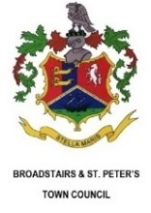 | Broadstairs & St. Peter’s Annual Transparency Statement

Time period covered by the statement:_______1st April 2020- 31st March 2021_________
Assets:
List of land and buildings owned by Broadstairs & St. Peter’s Town Council
Pierremont Hall, CT10 1 JX
The Music Room, CT10 1JX
The Cottage, CT10 1JX
Retort House, CT10 1NE
The area of Pierremont Park on the hard standing
Mockett’s Wood
Norman Road Allotments
Prospect Place Allotments
Bandstand and Bandstand Kiosk (Long lease from TDC)
Culmer’s Amenity Land (leased from the CT10 Parochial Charities)
Does the Town Council own any social housing assets? No
How many parking spaces did the Town Council have available for hire in the statement period? 16
How much money has been earned from parking in this statement period? £5250
Grants:
Total amount of grants awarded to community groups and organisations in the statement period: £33,600.
Link to grant policy: https://www.broadstairs.gov.uk/_UserFiles/Files/_Documents/Grant%20Criteria%20adopted%2025th%20September%202017.pdf
Staffing and Salaries:
Does the Town Council pay any salaries above £50,000 per year? No

Organisational chart of the Town Council: (diagram of organisational chart of the Town Council)
Town Clerk
Events Manager
Deputy Town Clerk
Caretaker

Marketing
Senior Administrator
Town Sergeant (post vacant from 31-07-20)
Mayor’s Secretary (post vacant from 29-05-20)

Are any staff members, members of a trade union? yes
Please set out the Pay Multiple of the Town Council:
The pay multiple compares the salary of the highest taxable earnings paid to a member of staff with the median earnings figure of all Broadstairs Town Council Staff as at the end of the 2019-20 financial year.
Highest paid: £40,876
Full time equivalent median pay: £27,005
Fraud:
Has the Town Council been investigated or fined over any fraudulent activity in the statement period? No

Signed:___________ 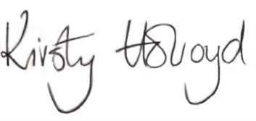____Responsible Financial Officer

